test case fails
1) i want to login the student dashboard with the admin's login gmail it was logged in so it not secure so you can carefully reroutes this error and solve root cause.
so i want no admins mail can br used any other unauthoried person so only "student cannot use the admin gmail and password to login the student dashboard it violates the security so check it
also same issue for the admin. admin can use the student gmail and password for the admin logged in so i want admin also do not use the student login gmail and password
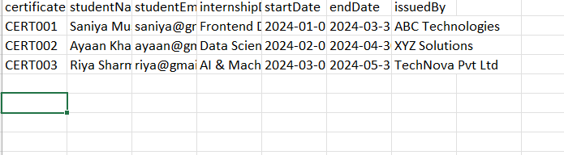
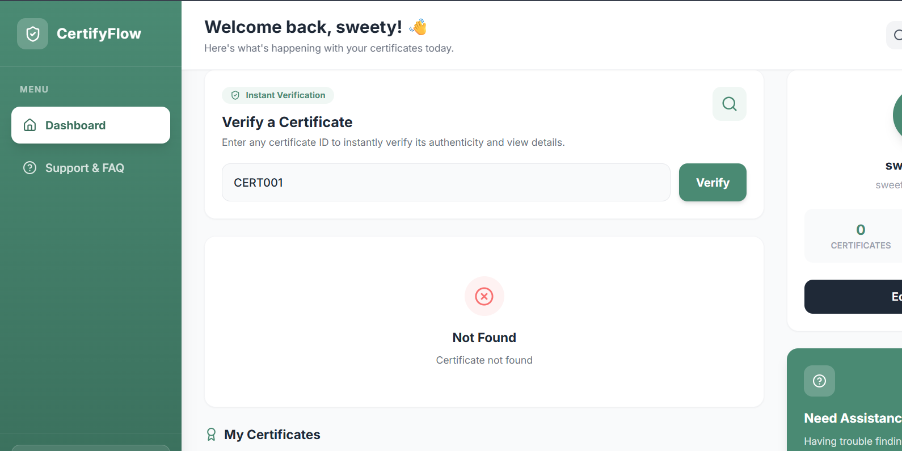

see these two scrrenshot see the error
the certificate id are present in the excel but they cannot be verify by the student so fixed this properly and reroutes the cause root and fixed it properly

Excel Upload - Strict Row-Level Validation
- Pre-validation phase: ALL rows validated BEFORE any inserts
- Checks for duplicates within the file
- Checks for existing IDs in database
- Validates: certificateId, studentName, internshipDomain, email
- Validates: dates are valid AND startDate < endDate
- Returns detailed errors with row numbers

Revoke Functionality
- Admin can revoke/restore certificates
- Revoked certificates blocked from download
- Clear error message to students: "This certificate has been revoked"
These cannot be worked see in the aboce screenshot there is no visible “download certificate button” and “view” button
“Authentication Tests
- Login with valid admin credentials → should succeed
- Login with wrong password → should fail
- Student cannot access admin routes → should be blocked

📊 Excel Upload Tests
- Upload valid Excel file → records saved in MongoDB
- Upload Excel with duplicate certificateId → should fail
- Upload Excel with missing fields → should reject row
- Upload empty Excel → error message

🎓 Student Certificate Tests
- Search valid certificateId → certificate shown
- Search invalid certificateId → “Not Found”
- Download certificate → PDF generated
- Revoked certificate → status shown as revoked

🔄 Data Sync Tests
- Admin deletes certificate → student search fails
- Admin uploads new Excel → student can immediately search
- Student download increases downloadCount (if added)
“
these all cases are failed not one case success so make this cases success do this property

